School Bell Times
Mendaram Pre Nursery
Monday to Friday | 7:40am – 11:30am
Mendaram Nursery
Monday to Thursday | 7:40am – 12:00pm
Friday | 7:40am – 11:45am
Rampayoh P1
Monday to Tuesday | 7:40am – 2:05pm  Breaks: 9:00am – 9:30am  : 11:30am – 12:20pm
Wednesday to Friday | 7:40am – 11:45am  Break : 9:00am – 9:30am
Rampayoh P2 and P3
Monday to Thursday | 7:40am – 2:05pm  Breaks: 9:00am – 9:30am  : 11:30am – 12:20pm
Friday | 7:40am – 11:45am  Break : 9:00am – 9:30am
Teraja P4 to P7
Monday to Thursday | 7:30am – 2:20pm  Breaks: 9:25am – 9:55am  : 11:45am – 12:35pm
Friday | 7:30am – 12:00pm
Melilas M1 to M2
Monday to Thursday | 7:20am – 2:20pm  Breaks: 9:30am – 9:50am  : 11:50am – 12:30pm
Friday | 7:20am – 12:00pm
Assembly – Friday
Rampayoh: 10:45am
Teraja: 11:10am
Welcome to Panaga School

New Family Arrival Information
This booklet provides information to assist you and your child to settle into Panaga School. We encourage you to also continue conversations with your child's class teacher in the first instance, to help familiarize yourself with school processes.

Panaga School's leadership team consists of Year Group Leaders, Deputy Head Teachers and Head Teachers located on Rampayoh/Mendaram and Teraja/Melilas school sites, with our Principal who oversees the management of Panaga School in its entirety. This leadership team are also available to assist you with relevant conversations.

We look forward to getting to know yourself and your family better as we work together in your child's learning journey.

Important Information:
- Absences - in the event that your child is unexpectedly absent (sick), please email: studentabsence@panagaschool.net or phone 3372694 (Mendaram/Rampayoh) or 3372139 (Teraja/Melilas). Please note there is a policy for exclusion periods for infectious conditions that has been created by medical staff at Panaga Health Centre with Panaga School staff. If your child will be absent from school for short or long leave, please visit the school office to complete a leave form.
- Parents and visitors on site. If on site before or after usual school drop off and pick up times, or when attending scheduled school events, you will be required to sign in at the front foyer security desk and wear a visitor's tag. Rampayoh foyer is the only entry point for Mendaram outside of usual arrival and departure times.
- Lateness - for students in Mendaram, please report directly to the class teacher. For students in Rampayoh, Teraja/Melilas, please report to the school front office where a late pass will be issued and recorded against school attendance.
- School requirements: students from P1 and above require a PE and sports house coloured T Shirt. All students require a bag, water bottle, snack/lunch and hat. Check with your child's class teacher to learn what days your child's class attends specialist lessons.
- Parent contact details - please ensure as soon as you move to temporary and permanent housing, the school is updated with all contact details.
- School Transport - There are designated drop off zones at both Rampayoh (students P1 to P3 only), Teraja/Melilas. Rampayoh drop off zone is next to the kitchen and is staffed between 7.30am and 7.40am.

School Starting Age
Year 2018/2019 Academic Year Enrolment
M2  12 / 13 YRS | 1ST SEPT 05 | 31ST AUG 06
M1  11 / 12 YRS | 1ST SEPT 06 | 31ST AUG 07
PRIMARY 7  10 / 11 YRS | 1ST SEPT 07 | 31ST AUG 08
PRIMARY 6  9 / 10 YRS | 1ST SEPT 08 | 31ST AUG 09
PRIMARY 5  8 / 9 YRS | 1ST SEPT 09 | 31ST AUG 10
PRIMARY 4  7 / 8 YRS | 1ST SEPT 10 | 31ST AUG 11
PRIMARY 3  6 / 7 YRS | 1ST SEPT 11 | 31ST AUG 12
PRIMARY 2  5 / 6 YRS | 1ST SEPT 12 | 31ST AUG 13
PRIMARY 1  4 / 5 YRS | 1ST SEPT 13 | 31ST AUG 14
NURSERY  SEPT INTAKE | 1ST SEPT 14 | 31ST AUG 15
PRE-NURSERY  SEPT INTAKE | 1ST SEPT 15 | 31ST AUG 16

School Leadership Team
Principal  Cindy Bin Tahal | 3372355 / 8777028 | cindybintahal@panagaschool.com
Head Teacher Teraja/Melilas
TBC
Head Teacher Mendaram / Rampayoh
TBC
Senior Admin Support  Jalinah Bte Ali | 3375728 | jalinah.ali@shell.com
Admin Support Mendaram / Rampayoh  Zurimah Bte Jumat | 3372694 | z.jumat@shell.com
Admin Support Teraja  Hasmah Bte Hj Salleh | 3372139 | hasmah.salleh@shell.com
Pre-Nursery Year Group Leader |  | Claire Richmond
Nursery Year Group Leader |  | Louise Ramsden
P1 Year Group Leader |  | Louise Cooke
P2 Year Group Leader |  | Rachel Marsden
P3 Year Group Leader |  | Laura Wilson
P4 Year Group Leader |  | Jo Marshall
P5 Year Group Leader |  | Tania Mehlhopt
P6 Year Group Leader |  | Matt Perryman
P7 Year Group Leader |  | Danni Cairns
M1 Tutors |  | Neil Lynch  Stephanie Straatman
M2 Tutors |  | Suzana Brooke

Mendaram students must be dropped directly to their class teacher and collected from their classroom everyday. Students in Rampayoh are able to be dropped off at the drop off zone or inside the school foyer from 7.30am each day, however must be collected directly from the classroom at the end of each school day. Students in Teraja/Melilas are able to independently walk or cycle to school. Panaga School practices safe travel behaviours by always wearing a seat belt in cars, always wearing a helmet when riding a bike and always parking cars in designated car parks.
- Class Parent Representatives- be sure to get contact details for your class parent representative. Parent Reps assist with school communications and classroom operations.
- Student Birthdays – We are happy to celebrate students’ birthdays at a time that suits the class timetable. Parents are asked to speak with the class teacher about a suitable time and item to bring to school (eg. Small cupcakes). We do not distribute party bags at school as such items cause several complexities (such as allergy management, choking hazards). Unless birthday invitations are being offered to all members of the class, we ask that birthday party invitations are not distributed using school communication systems (eg. Placed in younger children’s drawers).
- Pork free zone – Out of respect for our Muslim population, pork products are not to be in school.
- Student Medical Information – Please keep teachers and school office staff up to date with any relevant medical information about your child. Some students require certain medications to be left at school with Student Medical Plans available for all staff to access.

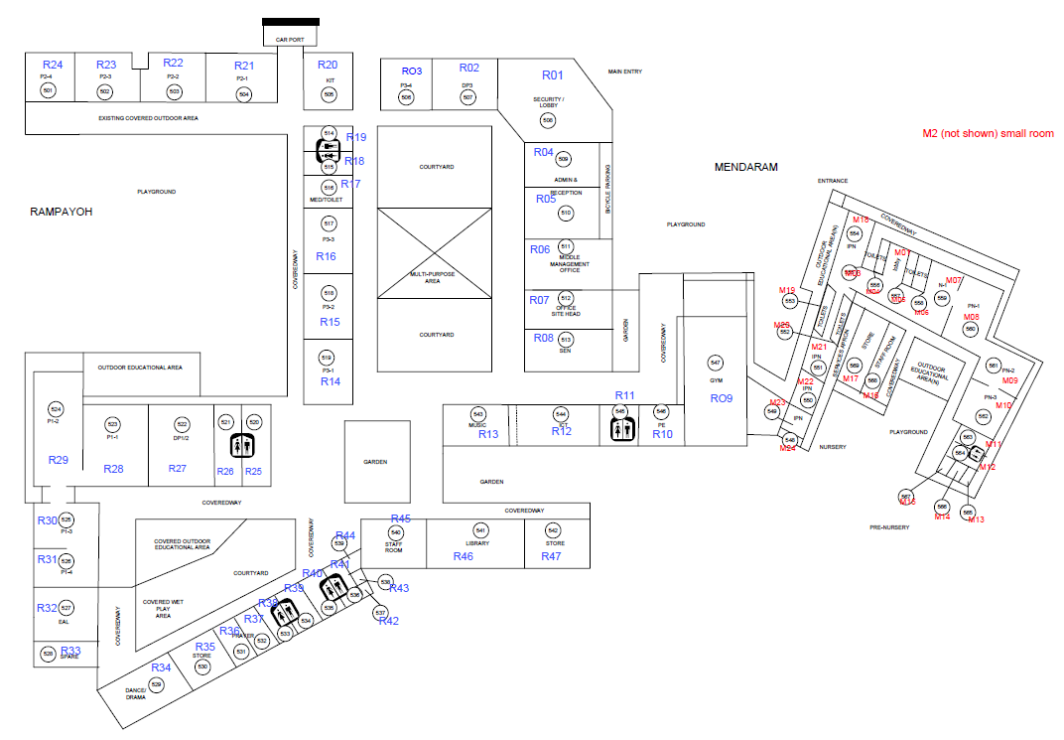
Mendaram
School Maps

Rampayoh

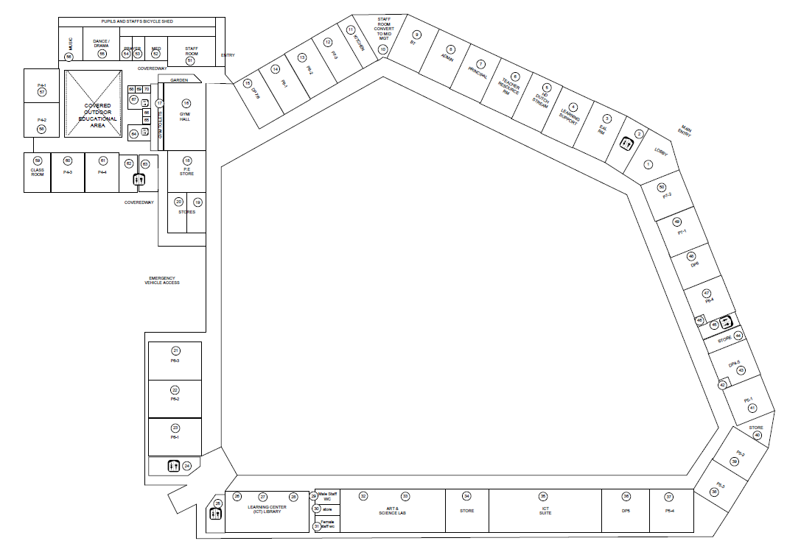

Teraja

Melilas

