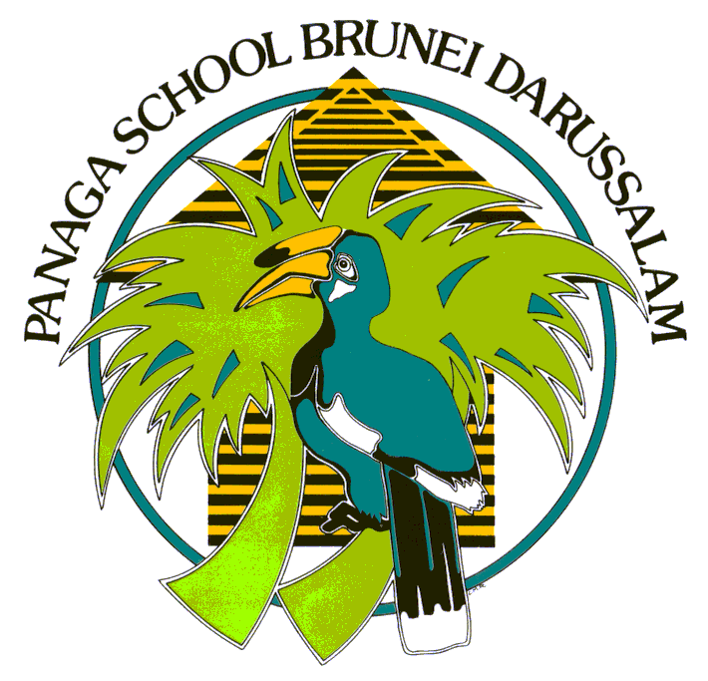
Panaga School
Brunei Shell Petroleum
Application for Admission
Panaga School is a mainstream school and offers very limited support for children with special educational needs. In cases where there is a requirement to cater for such a need, parents MUST contact the Principal of Panaga School (Cindy-Rose.BinTahal@bsp-shell.bn IFM/4) for advice and to establish if local support is available before coming to Brunei. Failure to contact the school before arrival, will in some cases delay the admissions process and your child will not be admitted to the school until we have all the correct documentation and support in place. A place at Panaga School is not guaranteed, if you have any doubts always contact the school for guidance. Please also be aware that Panaga School will ask your child’s current school for academic, behavior and personal information in support of your child’s application for admission.
Please be assured that all information provided below will be kept strictly confidential and be used only for the purpose of evaluating children for admission and record purposes once they have been accepted.
Please also refer to Terms and Conditions of Admission below.
- Student’s Details
Forename: | Surname: Male  Female | Please attach a recent photo (last 12 months)
Preferred Name: | Nationality:
Date of Birth: (DD/MM/YYYY) | Place of Birth:
Siblings at Panaga School (Name/Class)

Applying to enter year group (please see policy for guidance)

Intended starting date at School:

- Previous School(s) attended
School Name:  Address:  Phone Number: | Date Entered: (MM/YYYY)  Date Left: (MM/YYYY)  Type of Curriculum (E.g. IPC, PYP) | Current Year or Grade
School Name:  Address:  Phone Number: | Date Entered: (MM/YYYY)  Date Left: (MM/YYYY)  Type of Curriculum (Egg. IPC, PYP) | Current Year or Grade
Information on additional schools attended within the past 5 years should be sent as an attachment.

- Academic
Please indicate your child’s:

First language ……………………………………………………………………………..…………………………………………………………………………………………

Language most spoken at home……………………………………………………………………………………………………………………..………………………

Other languages spoken …………………………………………………………………………………………………………………………………………………………

If your child has attended an English-speaking school, for how many years? ………………………………………………..

Has your child been provided with additional support in the past? This may include but not be limited to Educational Psychologist / Occupational Therapist / Psychiatrist / Counsellor / Speech Therapist / Therapist / another specialist? | Yes No
If yes, please provide details and copies of any available reports with this admission application:

Panaga School currently offers an NTC program for children for whom Dutch is a Home Language. If you would like more information about this program, please check the box:

- Medical
Please detail any medical conditions your child may have, of which we need to be aware?

- Does your child have any ALLERGIES? Yes No If yes:

Allergic to: ………………………………………………… Typical Reaction: ……………………………………………………………..

Medication (if any) taken: …………………………………………………………………………………………………………………….

- Does your child take any medication (oral or injected) on a regular basis? Yes No

If yes, please provide details: ………………………………………………………………………………………………………………..

- Does your child wear glasses or contact lenses? Yes No
- Parent Details
Bruneian address (if known): | Bruneian emergency contacts (if known):  Name –  Relationship to child –  Contact number -
IT IS UNDERSTANDABLE THAT BRUNEIAN INFORMATION MAY NOT BE AVAILABLE AT THIS TIME. PLEASE ENSURE ONCE THIS INFORMATION IS AVAILABLE THAT PANAGA SCHOOL ADMISTRATION TEAM IS UPDATED AT THE SOONEST.
Pupil’s current address:  Telephone number: | Pupil’s base address:  Telephone number:
Pupil resides with (Please check all that apply)

Parents Father Mother Stepfather Stepmother Other (give details) ……………….
Father’s/Stepfather’s name:

Occupation: | Staff Category: IBAS TC Other
Father’s Department Indicator: | Father’s email address:
Father’s business address:

Mother’s/Stepmother’s name:

Occupation: | Staff Category: IBAS TC Other
Mother’s Department indicator: | Mother’s email address:
Mother’s business address:

I hereby certify that the above information is true and correct to the best of my knowledge.
Signature: | Name in Full:

The decision of the school regarding admission is final.
Panaga School reserves the right to amend these Terms and Conditions of Admission.

Terms and Conditions of Admission
Panaga School Mission Statement
Panaga School’s Mission and Vision is Together, Improving Learning. Student learning and progress on all levels is central to all that we do. This message is conveyed through an image of a whale silhouetted with animals, that represent the personal qualities. Our community is transient in nature, therefore the clear message of Together, Improving Learning helps all easily understand our mission.

Policy Purpose
To provide consistency of approach and a transparent process for admission to Panaga School.

Admission Policy
The children of Brunei Shell Joint Venture (BSJV) employees can enter school if all the relevant application criteria are met. The admission process must be completed before the first day of attendance. Any adaptation requests to the admissions policy is through an exception to policy process, submitted to both IFM and IFM/4.
IBAS Criteria:
- Children meet age eligibility for the school.
- The school can meet any additional learning requirements the child may have.

Panaga School Teachers’ Criteria:
- Children meet age eligibility for the school.
- The school can meet any additional learning requirements the child may have.
- Teachers are not benefitting from duplication of benefits.

Term Contracts / Direct Hires’ Criteria:
- Children meet age eligibility for the school.
- The school can meet any additional learning requirements the child may have.
- There are places available within the year group for which the child is eligible. *

Third Party Contractors’ Criteria:
- The child is a sibling of an existing third party contractor child, or an exception to policy has been approved. Exception to policy for third party contractors require a BSP Contract Holder letter of support for consideration, submitted to IFM and IFM/4.
- Children meet age eligibility for the school.
- The school can meet any additional learning requirements the child may have.
- There are places available within the year group for which the child is eligible. *

Non BSJV Criteria:
- Non BSJV admissions are available for M1 and M2, Middle Years, beginning August 2021.
- Children meet age eligibility for the school.
- Children have experience of a similar style education or demonstrate their academic capabilities to access learning in a mainstream, international curriculum.
- There are places available within the year group for which the child is eligible. *

If your personal circumstances or your child’s learning needs change, this may result in a review of admission.
*Class sizes at the school are limited and children of this category will be considered if there is available space. The usual terms and conditions of admission will still apply.

Age Eligibility Criteria
Enrolled year is usually based on the child’s age. Panaga School Leadership Team (SLT) will work collaboratively with families to determine if a child requires additional learning support of if a different year group is deemed academically and developmentally more appropriate.

Panaga School  Year Group Structure | Age Criteria  Birthday between  1st Sep and 31st Aug.  i.e. during academic year
Pre Nursery | 3rd Birthday
Nursery | 4th Birthday
Primary 1 | 5th Birthday
Primary 2 | 6th Birthday
Primary 3 | 7th Birthday
Primary 4 | 8th Birthday
Primary 5 | 9th Birthday
Primary 6 | 10th Birthday
Primary 7 | 11th Birthday
Middle School 1 | 12th Birthday
Middle School 2 | 13th Birthday

Note: Pre Nursery student Application for Admission is required prior to the 31st May of each year, in order to be guaranteed a place in the proceeding school year. After this date, if student numbers exceed staffing allocations, a student waiting list will be created.
Entrance Assessments
The school conducts entry assessments for children from Primary 1 to Middle School 2. Children in Pre Nursery to Primary 1 access two hours of orientation visit to prepare them for their transition into school.
Curriculum
Year Groups | Curriculum Followed
Pre Nursery, Nursery, P1 | International Early Years Curriculum (IEYC)
P2 to P7 | International Primary Curriculum (IPC)  Mathematics – The National Curriculum of England  English – The National Curriculum of England
M1 and M2 | The National Curriculum of England
The curriculum provision incorporates residential field trips and visits, which are integral to the education offered. Children are expected to follow the curriculum in full. Where parents opt not to include their child in residential visits lasting more than one night, the school will not provide alternative educational provision.
Inclusive Education
- English Language Support (EAL): An English Language or a Support Language programme will be offered if the pupil’s level of English prevents him/her from accessing the curriculum fully.
- Special Educational Needs (SEN): Panaga School is a mainstream school and offers very limited support for children with special educational needs. Where there is such a requirement, parents must contact the Principal (IFM/4) for advice and to establish if local support is available before coming to Brunei. Note: Failure to disclose any relevant information could result in the withdrawal of the child’s place if the school feels it cannot meet the child’s educational needs.
Where a child has been identified with a SEN before/upon/after admittance, or due to limited or reduced resources both within the school and locally, the school reserves the right to recommend alternative educational provision if the needs of the child cannot be met within the mainstream classroom. International School Brunei (ISB) manage and run an Inclusive Learning Centre for children with specific special education needs within Panaga residential area.

Medical
Parents are required to notify the school of any medical condition or need for regular medication. In a medical emergency, the school’s Senior Leadership Team may authorise referral to the Shell Panaga Health Centre for urgent treatment.

Code of Conduct
The day-to-day management of the school is the responsibility of the Senior Leadership Team and in educational matters their decision is final. Parents are referred to BSJV Code of Conduct, as well as relevant school policies, as available at https://www.panagaschool.com/policies .

Publicity
Parents and children agree that basic personal details and images may, from time to time, be used for the purpose of publicity and to celebrate learning. Any image taken of children in school by parents or their guests should not be published on social networking sites without the permission of the parents of the children in the image.

Assessment Data
Parents agree that the school may collect and store data on pupil progress against assessments made internally and through external testing (ISAs). Teacher assessment data is also stored through online systems including Google. Panaga School also uses apps such as Seesaw and Edmodo. All such data includes basic information relating to the children’s age, language and background to provide for effective analysis.

Student Pass
Brunei Government requires all expatriate children attending Panaga School to have a current student pass. For IBAS and Terms Contract BSJV employees, Panaga School Administration Officers, with BSP HR Immigration Team will lodge and manage student pass requirements with families. For third party contractors or expatriate open admissions, the following requirements apply:
- Student passes are to be directly applied for by the parents of third party or open admissions children, from the Ministry of Education in Bandar or via school administration.
- The school secretary can provide parents with the necessary form for making the application.
- Initial application for non BSJV employee’s child attending Panaga School must be applied for within the first two months of school attendance.
- The ‘green’ receipt from the Ministry must be returned to the school as proof of application.

School Fees
School fees are reviewed annually and may be subject to increase. There are three terms in the school year and fees will be charged on a per term basis. School fees will be published in advance of the academic year and will apply for the following three terms.
Year Groups | Termly Fees  (3 per year)
Middle Years 1 & Middle Years 2 | $4,500
Primary 1 to Primary 7 | $4,400
Pre Nursery & Nursery | $2,150

Costs for activities outside the core curriculum, such as residential field trips and visits, in which you agree in advance that your child may participate, are not included in the school fees and will be charged for accordingly.
BSJV employees are advised to refer to their contractual educational entitlement.
Payment Methods
Fees are payable prior to a child starting a school term. Payment should be made payable to:
Beneficiary: Brunei Shell Petroleum Co Sdn Bhd
Beneficiary Bank Details:
Standard Chartered, Kuala Belait, Brunei
SWIFT Code: SCBLBNBB
A/C No. 01001-418601-00

A full term’s fees will be payable if a child enters the school during the first half of a term. If a child enters the school after the half-term holiday in a given term, a half term’s fees will be charged. If a child leaves at the half term holiday in a given term (Final departure without returning to school), a half term’s fees will be charged. A half term’s fees are defined as 50% of a full term’s fees.

The decision of the school regarding admission is final. Panaga School reserves the right to amend these Terms and Conditions of Admission.

